Procedure Room Set Up
Before the patient is brought to the procedure room
- Monitors functional
- Oxygen source and delivery
- Scavenger operational
- Suction
- Airway adjuncts
- Defibrillator/AED
- Emergency medication/equipment
- Fire hazard precautions
with oxygen
- Necessary instruments, devices and materials present

Pre-Operative Encounter
With practitioner and patient
- Correct patient and DOB
- Correct radiographs present
- Correct procedure/side/tooth
- PMH, physical exam, medication reviewed
- Allergy/adverse drug reaction
- Essential medication maintenance
- Blood glucose evaluation
- ASA status/Mallampati class
- SBE/joint prophylaxis
- Pregnancy/lactation
- Escort present
- NPO status
- Informed consent
- Pre-operative vital signs
- Discussed with patient:
  - nausea/vomiting
  - sore throat
  - headache
  - potential tooth damage/other
- Dental assessment completed
  - Discussed risks
- c

Dental Assessment

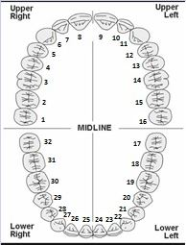

Tooth #
Chipped
Loose
Capped
Bonded
Bridge
Missing
Poor Dentition
Discussed w/patient

Post-Operative Recovery

- Patient awake and
breathing well
- Hemorrhage controlled
- Airway self-maintained
- Vital signs within 10%
of baseline
- Aldrete/pain score assigned
- Ice available
- Post-operative Rx
- Post-operative instructions
- Post-operative dental assessment

Records
- Operative notes written/dictated
- Anesthesia record complete
- Drug log complete
- Dental assessment documented
- c

